A novel hydrogen-based desalination system for a self-sustaining community
Du Wen^{a*}, François Maréchalª
ªIndustrial Process and Energy Systems Engineering, Swiss Federal Institute of Technology in Lausanne (EPFL), Rue de l’Industrie 17, Sion 1951, Switzerland
du.wen@epfl.ch
Abstract
This work proposes a novel hydrogen-based desalination system to replace fossil fuel-based plants. The system has a water-hydrogen nexus framework to achieve an efficient operation, providing electricity, potable water, and green hydrogen. Through optimal planning, less operation cost is found by considering the variation in supply and demand. Results show that the system has an average efficiency of 43.3%, higher than other renewable desalination systems. Meanwhile, the lower water production cost of 0.15$/t makes it competitive compared to membrane-based systems. The system well presents the merits of the water-hydrogen nexus.
Keywords: renewable energy, desalination, hydrogen, optimization.
  - Introduction
Thermal-based seawater desalination technologies, such as multi-effect distillation (MED), release the stress on the global water scarcity crisis. It has a long lifespan, great tolerance to feedwater salinity and quality, low prices, and strong scalability for various applications. However, it is energy-intensive, leading to considerable environmental problems and ecological risks (Lee et al., 2021). To compete with the membrane-based process, researchers are working on finding a way to integrate renewable energy into the thermal-based desalination system. The intermittent nature of renewable energy makes it unsuitable for continuous water supply. The promising solution to this erratic supply is energy storage technology, particularly chemical energy storage, such as power-to-gas. A certain chemical is produced using excess renewable energy and used in a supply shortage. Hydrogen is an up-and-coming candidate due to its zero-carbon fuel status and high energy density. Because of these qualities, it can be used to buffer the balance between supply and demand and facilitate the integration of renewable energy into desalination systems, particularly thermal-based systems where hydrogen can be used directly to produce thermal energy. Another heat source is the waste heat generated during the hydrogen production process.
Researchers have designed many systems to show the merits of this integration. Wang et al. (Wang et al., 2022) proposed a biomass-based system, comprising solid oxide electrolyzers, a biomass gasifier, a steam Rankine cycle, and MED units. Hydrogen is used to consume excess electricity, while the waste heat is used in MED units. The energy and exergy efficiencies of the system are 36.44% and 17.10%, respectively, with a freshwater production rate of 2.74 kg/s and a production cost of 16.6 USD/GJ. A hybrid energy system that integrates solid oxide fuel cells, a gas turbine, and proton exchange membrane (PEM) electrolyzers was studied by Musharavati and Khanmohammadi (Musharavati et al., 2022). Similarly, the waste heat is used in MED units. The system can produce 0.002 kg/s of hydrogen and 53.5 kg/s of desalinated water with an energy efficiency of 36.45%. Shahverdian et al. (Shahverdian et al., 2023) investigated the combination of solar, geothermal, PEM electrolyzers, MED, and Kalina cycle. The freshwater supply can reach 2.1 kg/s with an energy efficiency of 6.23%.
Those studies still have limitations, such as, they are not a net-zero system, hydrogen plays a single role of consuming excess electricity, and the nexus of energy, hydrogen, and water are not well displayed. According to those limitations, this work designs a novel hydrogen-based desalination system, which characterizes net-zero emission as it only uses renewable energy and hydrogen. Hydrogen is involved in the energy storage and MED processes. It is evaluated on different weather conditions throughout the year. The optimal system is determined by optimal planning. This work contributes to proposing a hydrogen-fueled system with relatively high energy efficiency and low cost.
  - Materials and methods
    - Scenario descriptions
The schematic of the hydrogen-based desalination system is shown in Figure 1. It provides electricity and freshwater to a community. This standalone net-zero system has two parts. In the power system, solar PV and wind turbine satisfy the electricity demand, while proton exchange membrane water electrolysis and fuel cells (hereafter, abbreviated as PEMEC and PEMFC, respectively) are used to deal with the mismatch between supply and demand. Excess electricity is stored in the form of hydrogen and released when needed. The second part is a MED system. Seawater undergoes an even distribution, dividing into four streams that are sprayed from the reactor's top. It experiences partial evaporation on the heat exchanger's surface and partial flashing upon entering the next stage from the bottom due to pressure changes. The resulting fluid, a mixture of evaporated and flashed seawater, combines with incoming seawater before being injected into the subsequent reactor. Meanwhile, the vapor produced progresses to the next-stage heat exchanger, where further condensation occurs. The necessary heat for the initial effect (E1) is supplied by a hydrogen-fueled boiler. Distilled water is directed into a flash box, separating flash vapor and condensed water.
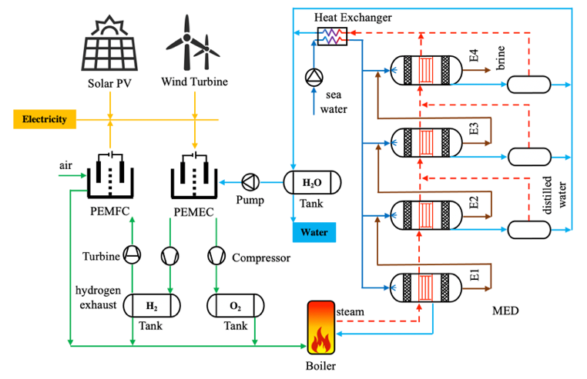
Figure 1. Schematic of the hydrogen-based desalination system.
    - Problem formulation
      - Objective function
The optimal planning of the system is described as a series of mixed-integer linear programming problems, of which the objective function is:
Obj=$\text{max}\left({REV}_{\text{t}}-\text{OPE}{\text{X}}_{\text{t}}\right)$ | (1)
where ${REV}_{\text{t}}$ is the revenue at time t, considering the revenue from selling electricity and hydrogen, USD; $\text{OPE}{\text{X}}_{\text{t}}$ is the operating expenditure at time t, USD.
$${\text{CAPEX}}_{\text{a}}\text{=}{\text{CAPEX}}_{\text{r}}{\left(\frac{{\text{A}}_{a}}{{\text{A}}_{r}}\right)}^{\text{n}}$$ | (2)
where ${\text{CAPEX}}_{\text{a}}$ is the capital expenditure of component a in the system, USD; ${\text{CAPEX}}_{\text{r}}$ is the capital expenditure of component a from the reference, USD; $\text{A}$ is the equipment cost attribute, which is determined by the specific component; $\text{n}$ is the cost exponent, -. The economic assumption is shown in Table 1.
Table 1 Economic assumptions (Wen et al., 2022, 2024).
Name | Value | Name | Value
System lifetime | 25 y | CAPEX of PEM stack | 385 USD/kW
CAPEX of solar PV | 1,166 USD/kW | CAPEX of desalination ª | 195.8 USD/(t/h)
CAPEX of wind turbine | 1,411 USD/kW | CAPEX of hydrogen storage | 90.1 USD/kg
ª The CAPEX of desalination is evaluated according to the reference (Turton et al., 2008).
      - Main constraints
The objective function is restricted by two main constraints, which are shown thereafter.
Energy balance constraint:
$$P_{demand}+P_{curtailment}=P_{solar PV}+P_{wind turbine}+P_{PEMFC}-P_{PEMEC}$$ | (4)
where $P_{demand}$ is the electricity demand from the community, kW; $P_{curtailment}$ is the curtailment caused by the supply and demand mismatch, kW; $P_{solar PV}$, and $P_{wind turbine}$, $P_{PEMFC}$ are the electricity generated by solar PV, wind turbine, and PEMFC, respectively, kW; $P_{PEMEC}$ is the consumed electricity by PEMEC, kW.
Mass balance constraints consider the storage limitation of hydrogen and portable water:
$${\text{m}}_{{\text{H}}_{\text{2}}\text{,sto}}^{\text{t}}\text{=}{\text{m}}_{{\text{H}}_{\text{2}}\text{,sto}}^{\text{t}\text{-1}}\text{+}{\text{m}}_{{\text{H}}_{\text{2}}\text{,}\text{PEME}\text{C}}^{\text{t}}\text{+}{\text{m}}_{{\text{H}}_{\text{2}}\text{,}\text{exhaust}}^{\text{t}}-{\text{m}}_{{\text{H}}_{\text{2}}\text{,MED}}^{\text{t}}-{\text{m}}_{{\text{H}}_{\text{2}}\text{,P}\text{EMFC}}^{\text{t}}$$ | (5)
$${\text{m}}_{{\text{H}}_{\text{2}}O\text{,sto}}^{\text{t}}\text{=}{\text{m}}_{{\text{H}}_{\text{2}}O\text{,sto}}^{\text{t}\text{-1}}\text{+}{\text{m}}_{{\text{H}}_{\text{2}}O\text{,M}\text{ED}}^{\text{t}}\text{+}{\text{m}}_{{\text{H}}_{\text{2}}O\text{,e}\text{xhaust}}^{\text{t}}\text{+}{\text{m}}_{{\text{H}}_{\text{2}}O\text{,}\text{PEMFC}}^{\text{t}}-{\text{m}}_{{\text{H}}_{\text{2}}O\text{,P}\text{EMEC}}^{\text{t}}-{\text{m}}_{{\text{H}}_{\text{2}}O\text{,s}\text{upply}}^{\text{t}}$$ | (6)
$$0≤{\text{m}}_{{\text{H}}_{\text{2}}\text{,sto}}^{\text{t}}≤M_{{\text{H}}_{\text{2}}\text{,}max},0≤{\text{m}}_{{\text{H}}_{\text{2}}O\text{,sto}}^{\text{t}}≤M_{{\text{H}}_{\text{2}}O\text{,}max}$$ | (7)
where ${\text{m}}_{{\text{H}}_{\text{2}}\text{,sto}}^{\text{t}}$ and ${\text{m}}_{{\text{H}}_{\text{2}}\text{,sto}}^{\text{t}\text{-1}}$ are the hydrogen storage capacity at time t and t-1, respectively, kg; ${\text{m}}_{{\text{H}}_{\text{2}}\text{,}\text{PEME}\text{C}}^{\text{t}}$ is the hydrogen production rate of PEMEC, kg/h; ${\text{m}}_{{\text{H}}_{\text{2}}\text{,}\text{exhaust}}^{\text{t}}$ is the remaining hydrogen in the exhaust gas of PEMFC, kg/h; ${\text{m}}_{{\text{H}}_{\text{2}}\text{,MED}}^{\text{t}}$ is the hydrogen consumption rate of MED, kg/h; ${\text{m}}_{{\text{H}}_{\text{2}}\text{,P}\text{EMFC}}^{\text{t}}$ is the hydrogen consumption rate of PEMFC, kg/h; ${\text{m}}_{{\text{H}}_{\text{2}}O\text{,M}\text{ED}}^{\text{t}}$ is the water production rate of MED, kg/h; ${\text{m}}_{{\text{H}}_{\text{2}}O\text{,e}\text{xhaust}}^{\text{t}}$ is the water production rate from hydrogen combustion, kg/h; ${\text{m}}_{{\text{H}}_{\text{2}}O\text{,}\text{PEMFC}}^{\text{t}}$ is the water production rate of PEMFC, kg/h; ${\text{m}}_{{\text{H}}_{\text{2}}O\text{,P}\text{EMEC}}^{\text{t}}$ is the water consumption rate of PEMEC, kg/h.
System component constraints are constructed based on (Wen et al., 2022).
Solar PV:
$$P_{solar PV}=η_{cell}P_{rated}\left[1+γ\left(t_{a}+I\left[\frac{t_{n}-20℃}{800W∙m^{-2}}\right]-25℃\right)\right]$$ | (6)
where $η_{cell}$ is energy efficiency of the solar cell, -; $P_{rated}$ is the rated power, kW; $γ$ is temperature coefficient, %/°C; $t_{a}$ is ambient temperature, °C; $I$ is solar irradiance, W/m²; $t_{n}$ is normal operating cell temperature, °C.
Wind turbine:
$$P_{wind turbine}=\frac{1}{2}ρA_{s}v^{3}C_{p}η_{m}$$ | (7)
where $ρ$ is air density, kg/m³; $A_{s}$ is the swept area of the rotor, m²; $v$ is the average wind speed at rotor height, m/s; $C_{p}$ is the power coefficient, -; $η_{m}$ is the mechanical efficiency.
PEMEL and PEMFC share a similar approach (Wen et al., 2022):
$$P_{PEMEC}=J_{PEMEC}V_{PEMEC}A_{PEMEC}$$ | (8)
$${\text{m}}_{{\text{H}}_{\text{2}}\text{,}\text{PEME}\text{C}}^{\text{t}}=\frac{J_{PEMEC}}{2F}M_{H_{2}}A_{PEMEC}$$ | (9)
where $J_{PEMEC}$ is current density, A/ m²; $V_{PEMEC}$ is the working voltage, V; $A_{PEMEC}$ is the membrane area, m²; $F$ is Faraday constant; $M_{H_{2}}$ is the mole mass of hydrogen, g/mol.
A hydrogen driven four-effect seawater desalination (MED) system is adapted from reference (Liponi et al., 2020) and modeled in Aspen Plus V11 (Aspen Tech, 2021). The system consists of a flash chamber, evaporator, demister, steam mixer, and condensation unit. The design parameters of the MED system are shown in Table 2.
Table 2 Design parameters of MED system.
Name | Value | Name | Value
Feed seawater | 5000 kg/h | Top brine temperature in effect 1 | 66.3 °C
Distilled water | 727.5 kg/h | Top brine temperature in effect 2 | 57.5 °C
Preheated seawater temperature | 40 °C | Top brine temperature in effect 3 | 48.8 °C
Recovery ratio in this work | 0.146 | Top brine temperature in effect 4 | 40.1 °C
    - Key performance indicator
Energy efficiency considers the main inputs and outputs of the system:
$$η=\frac{P_{solar PV}+P_{wind turbine}+P_{PEMFC}+{\text{m}}_{{\text{H}}_{\text{2}}\text{,}\text{PEME}\text{C}}^{\text{t}}LHVH+{\text{m}}_{{\text{H}}_{\text{2}}O\text{,M}\text{ED}}^{\text{t}}h_{water}}{P_{solar}+P_{wind}+{\text{m}}_{{\text{H}}_{\text{2}}\text{,P}\text{EMFC}}^{\text{t}}LHVH+{\text{m}}_{{\text{H}}_{\text{2}}\text{,MED}}^{\text{t}}LHVH}$$ | (10)
where $LHVH$ is the lower heating value of hydrogen, kJ/kg; $h_{water}$ is the specific entropy of the potable water, kJ/kg; $P_{solar}$ is the rated output of solar PV, kW; $P_{wind}$ is the wind energy potential, kW.
Annual Levelized cost of water (LCOW) denotes the production cost of freshwater:
$$\text{LCOW}\text{=}\frac{\sum{CAPEX\frac{i{\left(1+i\right)}^{n}}{{\left(1+i\right)}^{n}-1}}+\sum{OPEX}-\sum{REV}}{\sum{m_{{\text{H}}_{\text{2}}O\text{,M}\text{ED}}}}$$ | (11)
where $\text{n}$ is system lifetime, y; $\text{i}$ is annual interest.
  - Results and discussions
The system is examined on the yearly supply and demand data, which are provided by the MERRA-2 database (Global Modelling and Assimilation Office (GMAO), 2015) and the Renewable Energy Institute of Japan.
    - Technical performance
Figure 2. shows the hourly and monthly average of system efficiency. The distribution curves characterize a flattened bowl shape as depicted on the left. It is around 30% during the day, while it is around 55% during the night. The common effect of all subsystems contributes to this characteristic, where solar dominates the lowest efficiency and PEM electrolyzers domine the highest efficiency because the solar system has a maximum efficiency of 15.3% (less than the valley point of 25%) and PEM electrolyzers have a maximum efficiency of 70% (over than the peak point of 55%). The monthly variation mainly depends on solar output. In January, when there is less solar energy potential, the monthly average system efficiency is the highest. On the contrary, In June, the increasing proportion of solar output decreases the system efficiency.
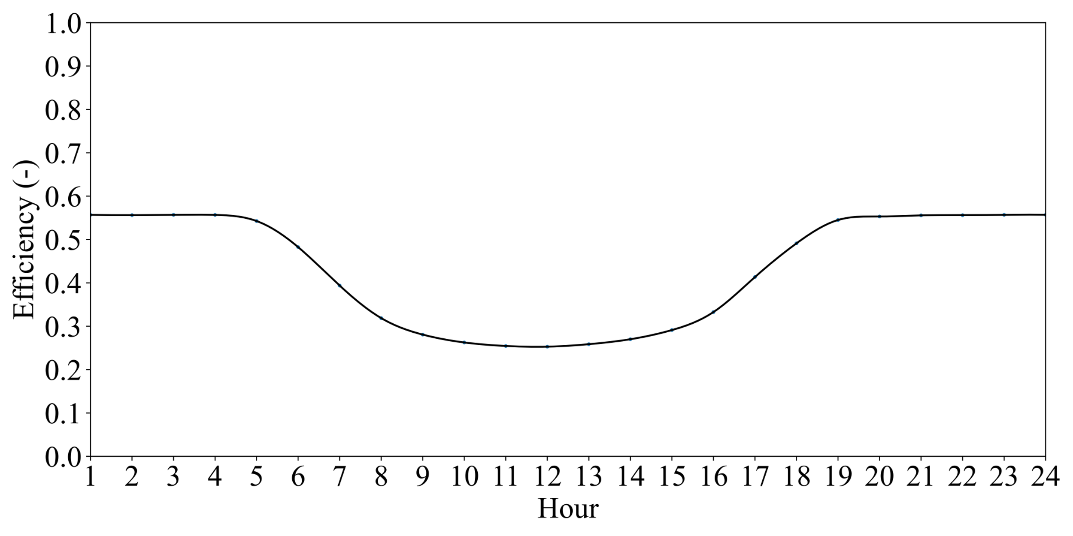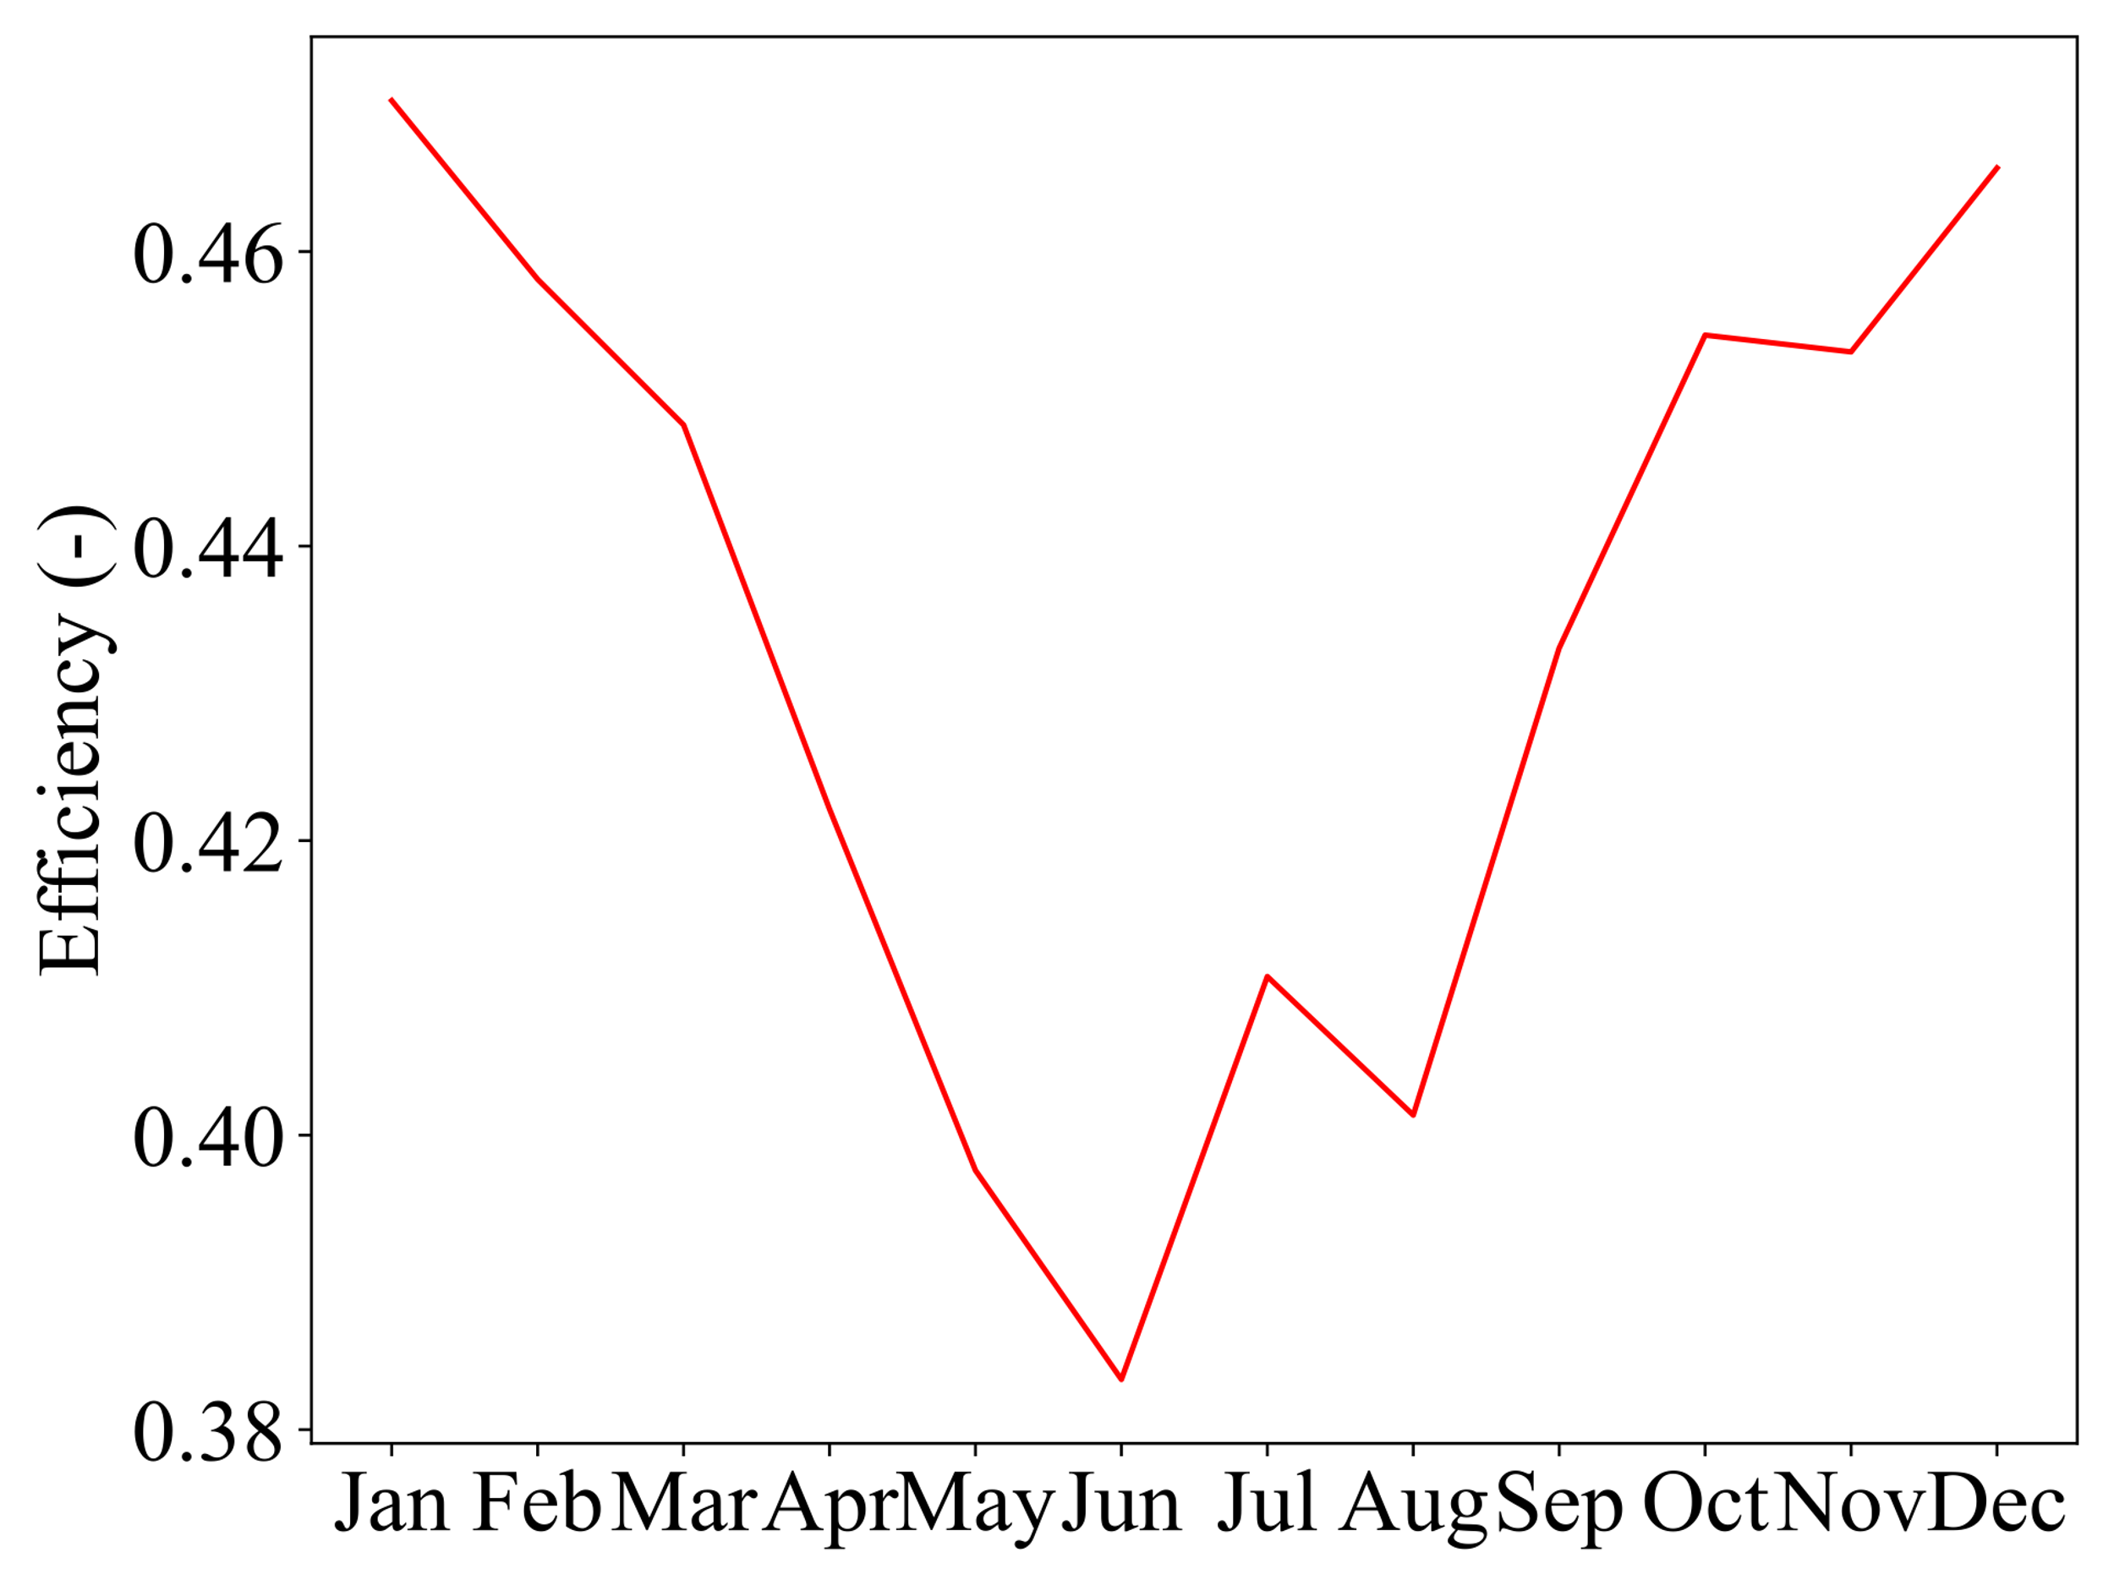
Figure 2. Hourly and monthly average of system efficiency.
The monthly share of net hydrogen production is shown in Figure 3. Because of the constant operation of the MED system, the variation is determined by PEMEC and PEMFC systems. The peaks occur in March, April, and October when there is a high utilization rate of the PEMEL system. Over 25 tones of hydrogen per month is accumulated at that time. The valley in August requires an extra 14.7 tones of hydrogen, which can be satisfied by the accumulation. The PEMFC system in August consumes almost double that in other months. The hydrogen consumption rate of the MED system ranges from 40 – 45 tones per month. The exhaust gas from the PEMFC system can be used to provide heat duty in the MED system for the sake of fuel saving.
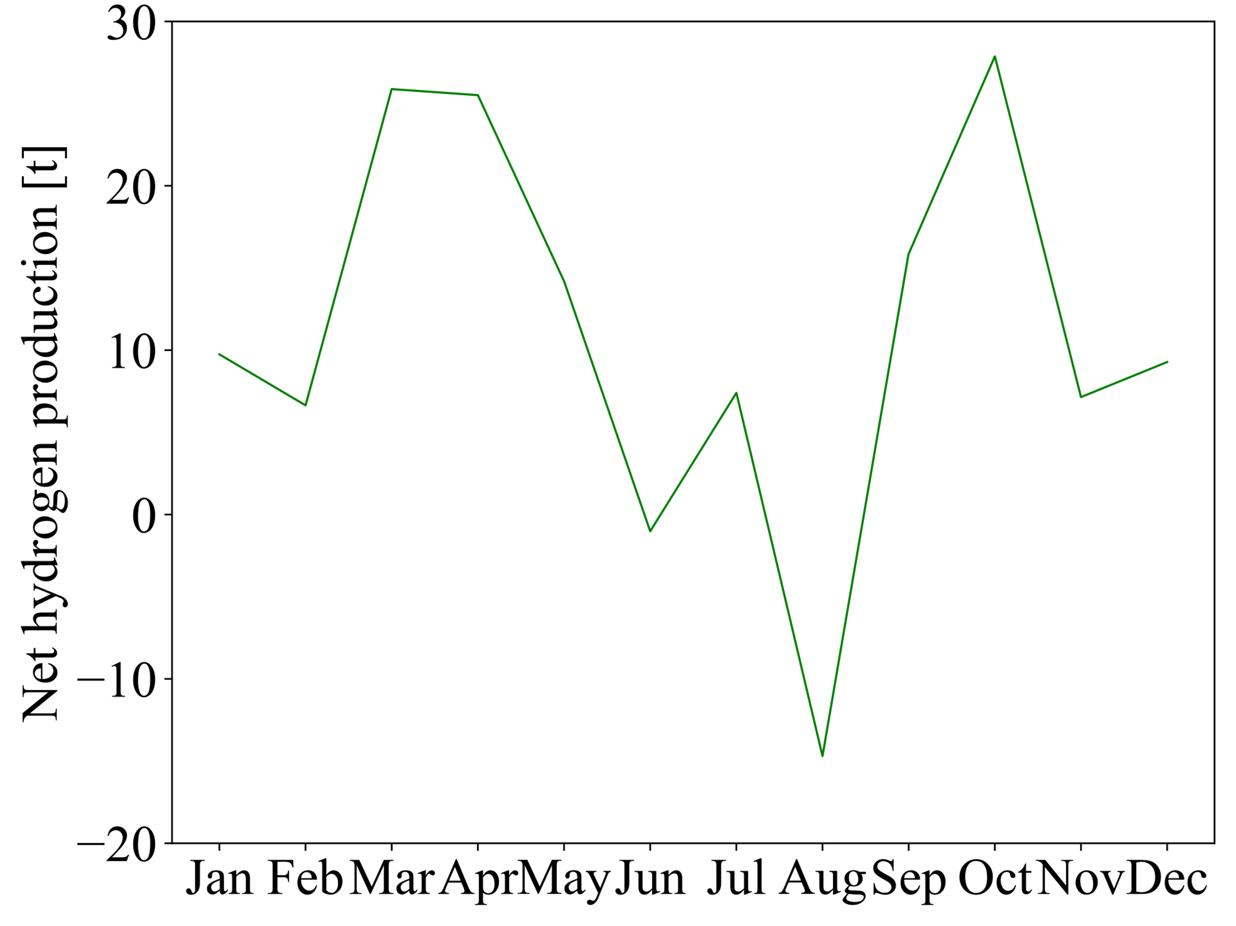
Figure 3. Monthly net hydrogen production.
    - Economic performance
The breakdown of CAPEX is shown in Figure 4. It is 51.3 MUSD in total, where wind turbine (WT) takes the majority of it, followed by solar PV, PEM electrolyzers, MED, and storage tank. Since the water, fuel, heating, and cooling are satisfied inside the system, only fixed OEPX is considered, which is 1.26 MUSD. The revenue from electricity and hydrogen makes the production cost of fresher water cheaper than expected, as shown in Table 3. Compared with other works, this system also has a high efficiency.
Figure 4. Breakdown of CAPEX.
    - Comparison with other systems
Table 3 Comparison of different desalination systems.
Configuration | Efficiency | Power supply | Hydrogen supply | Water supply | Cost | Ref.
This work | 43.3% | 8.2 MW | 12.1 kg/h | 9.7 t/h | 0.15 $/t | -
ORC, SOEC, AEC, RO | 37.9 % | 6.3 MW | 169.2 kg/h | 5.9 t/h | 1.86 $/t | (Lee et al., 2022)
Gasification, SRC, SOEC, MED | 36.4 % | 1.7 MW | 12.3 kg/h | 9.9 t/h | 16.6 $/GJ | (Wang et al., 2022)
Gas turbine, PEMEC, SOFC, MED | 36.5 % | 54.8 MW | 7.4 kg/h | 192.6 t/h | - | (Musharavati et al., 2022)
Solar, KC, PEMEC, PEMFC, MED | 6.2 % | 81.4 MWh | 1.3 kg/h | 7.6 t/h | - | (Shahverdian et al., 2023)
  - Conclusions
In this study, a novel hydrogen-based desalination system is proposed for a self-sustaining community. It uses hydrogen as a substitute for fossil fuels and as an energy carrier. It is a net-zero system and flexible enough to satisfy the fluctuating electricity demand, while at the same time providing a constant water supply. After the evaluation on the hourly supply and demand data, the conclusions are summarized as follows: the system has a higher energy efficiency of 43.3% and a lower production cost of 0.15$/t, compared to previous works. The system well presents the merits of the water-hydrogen nexus.
References
K. Lee, W. Jepson, 2021, Environmental impact of desalination: A systematic review of Life Cycle Assessment, Desalination, 509, 115066.
R. Turton, R.C. Bailie, W.B. Whiting, J.A. Shaeiwitz, 2008, Analysis, synthesis, and design of chemical processes, 3ed, Pearson Education.
Du Wen, Muhammad Aziz, 2022, Techno-economic analyses of power-to-ammonia-to-power and biomass-to-ammonia-to-power pathways for carbon neutrality scenario, Applied Energy, Volume 319, 119272.
Du Wen, Muhammad Aziz, 2024, Perspective of staged hydrogen economy in Japan: A case study based on the data-driven method, Renewable and Sustainable Energy Reviews, Volume 189, Part A, 113907.
A. Liponi, C. Wieland, A. Baccioli, 2020, Multi-effect distillation plants for small-scale seawater desalination: thermodynamic and economic improvement, Energy Conversion and Management, Volume 205, 112337.
Aspen Tech, Aspen Plus Simulation Software, 2021.
Global Modelling and Assimilation Office (GMAO), 2015, MERRA-2 tavg1_2d_rad_Nx: 2d,1-Hourly,Time-Averaged,Single-Level,Assimilation,Radiation Diagnostics V5.12.4, Greenbelt, MD, USA, Goddard Earth Sciences Data and Information Services Center (GES DISC).
J.M. Lee, S.H. Lee, J.H. Baik, K. Park, 2022, Techno-economic analysis of hydrogen production electrically coupled to a hybrid desalination process, Desalination, Volume 539, 115949.
S. Wang, H. Lin, A.M. Abed, A. Sharma, H. Fooladi, 2022, Exergoeconomic assessment of a biomass-based hydrogen, electricity and freshwater production cycle combined with an electrolyzer, steam turbine and a thermal desalination process, International Journal of Hydrogen Energy, Volume 47, 33699-33718.
F. Musharavati, S. Khanmohammadi, 2022, Design and exergy based optimization of a clean energy system with fuel Cell/MED and hydrogen storage option, International Journal of Hydrogen Energy, Volume 47, 26715-26727.
M.H. Shahverdian, S. Sedayevatan, M. Hosseini, A. Sohani, R. Javadijam, H. Sayyaadi, 2023, Multi-objective technoeconomic optimization of an off-grid solar-ground-source driven cycle with hydrogen storage for power and fresh water production, International Journal of Hydrogen Energy, Volume 48, 19772-19791.

